POSE MIRRORING USING NAO

A Capstone Project Report

Submitted to the Faculty

of the

Bennett University

By

Appasani S N V Chandu

E16CSE040

&

Kamal Sai Raj Kuncha

E16CSE028

In Partial Fulfillment of the Requirements

for the Degree of

Bachelor of Technology

Major Department: Computer Science Engineering

October 2019

Greater Noida-201310, Uttar Pradesh, India

# CERTIFICATE

I hereby certify that the work which is being presented in the B.Tech. Capstone Project Report entitled **“Pose Mirroring Using NAO”,** in partial fulfillment of the requirements for the award of the **Bachelor of Technology in Computer Science & Engineering** and submitted to the Department of Computer Science & Engineering of Bennett University Greater Noida UP is an authentic record of my own work carried out during a period from July 2019 to November 2019.

The matter presented in this thesis has not been submitted by me for the award of any other degree elsewhere.

Signature of Candidate

[Name of the student]

[Enrollment Number]

This is to certify that the above statement made by the candidate is correct to the best of my knowledge.

Head

Computer Science Engineering Department

Bennett University Greater Noida UP

ABSTRACT

The project “Pose Mirroring Using Nao” make the robot Nao mirror the pose and gesture of the user. This classifies the gestures of the user and tries to replicate the same thing as a mirror. These poses include the basic gestures like salute, rising one hand in the air, rising two hands in the air, folded hands, namaste etc. Humans usually do the mirroring of gestures in a social conversation; this helps in improving the social interaction. Using this on robots, if robots start doing this pose mirroring like humans do in an interaction the wellness of Human Robot Interaction will be very good. When the robot does that thing of mirroring the poses that the human in front of it is doing, it makes the humans think better about the way robots work and the capabilities of the robot. From the days of the robot advancement has come into limelight, there has always been a debate on the capabilities of robots being empathetic when they interact with humans. This problem is the main reason for this project to come into existence. To improve the perception of humans that robots aren’t empathetic towards humans during HRI we thought this vision of the project is very crucial. Imagine robots doing things like mirroring the poses while interacting with humans like humans do it will for sure make humans think better about the robot. This will create a positive impact on robots in human minds. This will help in the support to advance the robot technology which is paramount in the present time of technology advancement. Our project still has limitations and cannot solve the problem completely but having advancements to this project idea and the vision, the goal can be achieved.

ACKNOWLEDGEMENTS

Acknowledgements text should be placed here.

DEDICATION

This section dedicates the disquisition to a few significant people. The text must be double spaced and aligned center to the page.

**TABLE OF CONTENTS**

<<Right click on the heading and click update flied. Your heading will be pulled here. Same goes with all the table of content in the subsequent pages>>

ABSTRACT iii

ACKNOWLEDGEMENTS iv

DEDICATION v

LIST OF TABLES viii

LIST OF FIGURES ix

LIST OF ABBREVIATIONS x

1. INTRODUCTION 1

1.1. Problem Statement 1

2. Background Research 2

2.1. Proposed System 2

2.2. Goals and Objectives 2

3. Project Planning 3

3.1. Project Lifecycle 3

3.2. Project Setup 3

3.3. Stakeholders 4

3.4. Project Resources 4

3.5. Assumptions 5

4. Project Tracking 5

4.1. Tracking 5

4.2. Communication Plan 6

4.3. Deliverables 7

5. SYSTEM ANALYSIS AND DESIGN 9

5.1. Overall Description 9

5.2. Users and Roles 9

5.3. Design diagrams/ UML diagrams/ Flow Charts/ E-R diagrams 10

5.3.1. Use Case Diagrams 10

5.3.2. Class Diagram 11

5.3.3. Activity Diagrams 12

5.3.4. Sequence Diagram 13

5.3.5. Data Architecture 14

6. User Interface 15

6.1. UI Description 15

6.2. UI Mockup 15

7. Algorithms/Pseudo Code 17

8. Project Closure 18

8.1. Goals / Vision 18

8.2. Delivered Solution 18

8.3. Remaining Work 18

REFERENCES 20

LIST OF TABLES

Table Page

Table 1: Goal and Objectives 3

Table 2: Sample 2 3

Table 3: Sample 3 4

Table 4: Sample 4 4

Table 5: Sample 4 5

Table 6: Sample 6 6

Table 7: Regularly Scheduled Meetings 6

Table 8: Information To Be Shared Within Our Group 6

Table 9: Information To Be Provided To Other Groups 7

Table 10: Information Needed From Other Groups 7

Table 11: Deliverables 7

Table 12: Sample 12 10

LIST OF FIGURES

Figure Page

Figure 1: Sample use-case diagram 11

Figure 2: sample 2 12

Figure 3: sample 3 13

Figure 4: Sample 4 14

Figure 5: Sample 5 14

Figure 6: Sample 6 15

LIST OF ABBREVIATIONS

[Abbreviation] Explanation of the Abbreviation.

1. INTRODUCTION

The vision of the project is to improve the interaction between robots and humans. Our project makes the robot mirror the poses displayed by the user in front of it. Mirroring is a psychological technique used by humans naturally in any social interaction with other humans. Incorporating this into robots will be such an asset to the Human Robot Interaction. These poses include the basic gestures like salute, rising one hand in the air, rising two hands in the air, folded hands, namaste etc. Humans usually do the mirroring of gestures in a social conversation; this helps in improving the social interaction. This way the relation between humans and robots can be improved.

* 1. Problem Statement

Mirroring is a psychological concept that humans usually do while they are talking to other people. Psychologically it is proven that mirroring between humans happen more frequently when they are in group. This mirroring helps in better social interactions and makes the person more empathetic towards others. The most important thing that misses in the Human Computer Interaction is the empathy and the rapport between the humans and the robots. This has been a crucial issue since the Human Computer Interaction has come into limelight. Our project solves this problem to some extent as the mirroring human gestures and poses improves the interaction and develops an empathetic and a human feeling when the interaction is taking place.

1. Background Research

<<There have been many studies on the domain of HRI and how mirroring improves HRI and the perspective of humans about robots[1]. There is one paper written by Salem in which it is stated that humans have the tendency to anthropomorphize (to like the robot more). This paper also states that the interaction with humans is increased if the robots are using gestures instead of staying still[2]. There is one more paper by the same authors where it says that robots using gestures can enhance human’s performance on robot guided tasks[3]. Robots that perform gestures also increases the level of co-operation that humans do with the robots[4]. The gestures and usage of mirroring techniques can create the rapport between humans and robots. This helps in having better Human Robot Interaction and is a very crucial part when it comes to HRI[5].

There is a research paper in which the researchers worked on impact of facial expressions on HRI[6]. In this the researchers made robots interact with humans int two ways, one they have the expressions on and in the other without expressions. After this they analyzed the perspective of humans on the robots in both the aspects one while having the expressions and one without expressions. The feedback was taken in the form of questionnaire, where in one the evaluation is for empathy and subjective evaluation and the other is the five Godspeed questionnaire. The result was that the robot with expressions had a better feedback and humans were connected more with that robot than the one without the expressions[7]. This result was supported by another research paper by Kanda[8].

There are different research papers in this domain with a lot of sub domains like humans’ demonstrations, human social interaction using humanoid robots etc. The research papers[9]–[12] have worked on the imitating humans gestures domain where they say that imitating humans gestures while speaking helps the robots to develop a rapport between the human interacting with them and the robot. The research on human demonstration of gestures to robots[9], [13] states that with the demonstration of gestures to robots, they can be trained to perform the gesture mirroring tasks to improve the Human Robot Interaction. There are few research papers on Human Social Interaction using Humanoid Robots[14], [15] which explains how HRI is effected with respect to the social interaction that humans usually have.

* 1. Proposed System

This project aims to improve the perspective of humans on robots. This will be achieved by making robots respond to the gestures of the humans. This is the way in which robots mimic the actions of the humans which usually humans do in social interactions. This will be an excellent addition to the Human Robot Interaction. Humans usually think robots aren’t empathetic enough to humans, after experiencing this there are very high chances of humans changing their perspective. By achieving that there is a greater push from humans to the advancements of robotics.

* 1. Goals and Objectives

There were different goals and different objectives in different phases of the project. Few goals and objectives at different phases of the project are mentioned in the tables below.

Table : Goal and Objectives for Background Research

|  |  |
| --- | --- |
|  | **Goal or Objective** |
| 1 | Read research papers and watch videos around the domain of Human Robotic Interaction. |
| 2 | Narrow down the research papers to the pose mirroring concepts on different robots. |
| 3 | Read research papers about the pose detection techniques using Machine Learning. |
| 4 | Find out the best suitable papers in both the domains and use them as the reference papers in the future work. |

Table 2: Goal and Objectives for Feasibility of Project

|  |  |
| --- | --- |
|  | **Goal or Objective** |
| 1 | Understand the functionalities and limitations of Nao |
| 2 | Work with the software of the Nao and learn the technicalities and joint moments. |
| 3 | Learn about the feasibilities of the interaction between Nao and machine learning algorithms. Talk to different faculty about the different ways of doing this. |
| 4 | Study the ways of Machine learning techniques and using those results as input forms to Nao to perform actions. |

Table 3: Goal and Objectives for Main Project

|  |  |
| --- | --- |
|  | **Goal or Objective** |
| 1 | Work on the deep learning model to detect and classify the different human gestures. Check different models and finalize one model which is more accurate and implementable. |
| 2 | Prepare dataset of poses to train and test on the machine learning model developed. Then use the output exoskeleton models as another dataset. |
| 3 | Train Nao for different body postures basing on the number of classifications the deep learning model have. |
| 4 | Check the accuracy of the deep learning model output after proper training and testing. |
| 5 | Work on the compatibility of the Nao with the Deep Learning model outputs. Like how we can use those results on Nao and make Nao respond accordingly. |
| 6 | Document the work that is done and the way the work is done properly in a report format. |

1. Project Planning

The project planning of our project is as given below:

* 1. Project Lifecycle

Our team is using a Machine Learning approach to identify or classify the poses given by the subject then a ML model which is already trained on some data will classify the pose of the user. This will be given as input to the Nao and Nao will perform the action. The action that Nao performs is predefined. We define some action according to the number of classifications in the ML model. These predefined actions will be performed when required.

* 1. Project Setup

The basic project decisions description are mentioned in the table below:

Table 4: Sample 2

|  |  |
| --- | --- |
|  | **Decision Description** |
| 1 | Windows 10, Choreographe, Memory Backup by Nao, Nao Documentation, Git etc. |
| 2 | Standards that must be followed (default Capstone coding standard, etc.) |
| 3 | The Nao will be used from the CSE Dept for the work on the project. |

* 1. Stakeholders

The stakeholders of the project are as detailed in the table below:

Table 5: Stakeholders Table

|  |  |
| --- | --- |
| **Stakeholder** | **Role** |
| Dr. Deepak Garg | Sponsor of the Robot Nao |
| Dr. Tapas Badal | Mentor |
| Kamal Sai Raj K | Team Member |
| Chandu Appasani | Team member |

* 1. Project Resources

The anticipated resources that are required for a successful completion of this project are listed in the table below. The description of the resources and the quantity required are also mentioned in the table below.

Table : Sample 4

|  |  |  |
| --- | --- | --- |
| **Resource** | **Resource Description** | **Quantity** |
| Nao Robot | The Robot Nao which was bought by our CSE Department | 1 |
| Capstone Team | Our team of students who will be the primary developers of the project. | 2 |
| Dr.Tapas Badal | The mentor who will be able to provide us with technical assistance and also helps us in giving required details during documentation | 1 |
| GD Room | A room which is isolated and has a table or carpet to work on Nao | 1 |

* 1. Assumptions

The table below consists of the assumptions on which the project was based be it the assumptions are made in the initial days of the project or during the later phases.

Table : Sample 4

|  |  |
| --- | --- |
| **No.** | **Assumption** |
| A1 | The capstone team and mentors will be able to meet face to face once a week. |
| A2 | The humanoid robot Nao will be available whenever it is required to do the work. |
| A3 | Team members will be able to familiarize themselves with the Nao robot, choreographe software of the Nao. |
| A4 | Team will have enough time to complete a working model to present by mid-semester |
| A5 | Machine Learning model to classify poses will be completed on time to train the Nao based on the number of classifications to be done. |
| A6 | The test data that will be developed will be enough to get good accuracy of the Machine Learning Model. |
| A7 | The connection between the Nao and Machine Learning model can be made using some relevant platforms. |
| A8 | The provided financial help will be provided if the use of cloud architecture is required to process the ML models and feed the results to Nao. |

1. Project Tracking
   1. Tracking

<< Provide information about how the project was tracked and where information was kept. This should include information such as what type of source control was being used and how it can be accessed, any bug-tracking system that was used for the project and where it can be accessed, what type of regressing testing suite was used and where it can be accessed, and any similar information that provides details on the project’s status, etc. >>

**Example:**

Table : Sample 6

|  |  |  |
| --- | --- | --- |
| **Information** | **Description** | **Link** |
| Code Storage | Project code will be stored in SVN repository. | Link |
| Bug Tracking | Bug tracking will be done with Trac. | Link |
| Project Documents and Assignments | Weekly reports, specification and design documents, etc. will be stored in our SVN repository. | Link |
| Continuous Integration | Continuous integration will be done with Jenkins. | Link |
| Regression Testing | Regression testing will use JUnit unit tests and Jenkins. | Link |

* 1. Communication Plan

The following tables give the details of meeting, communications between the team members and mentors, the frequency of the meetings and the purpose of the types of meeting.

Table : Regular Meeting Schedule

|  |  |  |
| --- | --- | --- |
| Meeting Type | Frequency/Schedule | Who Attends |
| Team Meeting | Weekly | Team Members and mentor |
| Team Meeting | Twice a week | Team Members |
| Sprint Planning Meeting | Start of each sprint | Team Members and mentor |
| Sprint Retrospective Meeting | End of each sprint | Team Members |
| Sprint Review Meeting | End of each sprint | Team Members and Mentor |

Table : Information To Be Shared Within Our Group

|  |  |  |  |
| --- | --- | --- | --- |
| Who? | What Information? | When? | How? |
| Team Members | Task assignments and division of work | Twice a week | Team meetings, listing in Project Specification. |

Table : Information To Be Provided To Other Groups

|  |  |  |  |
| --- | --- | --- | --- |
| Who? | What Information? | When? | How? |
| Sponsor and mentor | Final deliverables | At completion of project | Project specification doc., code, Power Point presentation, final demo |

* 1. Deliverables

The major deliverables of the project are as mentioned in the tables below. These include the final deliverables like the documentation, code, video, demo etc.

Table 10: Deliverables

|  |  |
| --- | --- |
|  | **Deliverable** |
| 1 | Code |
| 2 | Test and test results of ML model |
| 3 | Final Report |
| 4 | Final PowerPoint Presentation |
| 5 | Video with the explanation of the project |
| 6 | Final Demo of the working mode of the project |

1. SYSTEM ANALYSIS AND DESIGN

This includes the overall description of the project, user types and the description of the users and their tasks.

* 1. Overall Description

The project is an attempt to improve the interaction between robots and humans. Our project makes the robot mirror the poses displayed by the user in front of it. Mirroring is a psychological technique used by humans naturally in any social interaction with other humans. Incorporating this into robots will be such an asset to the Human Robot Interaction.

From the days of the robot advancement has come into limelight, there has always been a debate on the capabilities of robots being empathetic when they interact with humans. This problem is the main reason for this project to come into existence. To improve the perception of humans that robots aren’t empathetic towards humans during HRI we thought this vision of the project is very crucial. Imagine robots doing things like mirroring the poses while interacting with humans like humans do it will for sure make humans think better about the robot. This will create a positive impact on robots in human minds. This will help in the support to advance the robot technology which is paramount in the present time of technology advancement. Our project still has limitations and cannot solve the problem completely but having advancements to this project idea and the vision the ultimate goal can be achieved. The limitation of our project is that we are using backend system to send the result of the pose classification to the robot. If this can be eliminated by using robots with high processing power or using proper and appropriate cloud computing techniques this project can be an immense support in solving the problem stated. This way the problem can be solved to the core of it.

* 1. Users and Roles

The table below explain the different types of users of the project in the process of making it and in the process of executing it.

Table 11: User types and Their Description

|  |  |
| --- | --- |
| **User** | **Description** |
| Developer | A capstone team member whose task is to manage the data, develop the Machine Learning models to classify the pose, train the Nao for performing different actions according to the classifications made by the ML model and finally testing it. |
| Mentor | A mentor will be helping us in understanding the complex thing, provide the templates for the documentation of the project and shows us a way to display the project to the potential user. |
| Potential User | Potential User is the end user that basically uses the project. This user the most important and the person that needs to be satisfied with the project. |

* 1. Design diagrams/ UML diagrams/ Flow Charts/ E-R diagrams

<<provide all the diagrams that were created during the design phase of your project. Some examples are in sections below:>

* + 1. Use Case Diagrams

<< Provide any use-case diagrams that are being used as part of the project. Uniquely label each use case so that if necessary, it is easy to reference from other parts of the document. >>

**Example:** Restaurant system

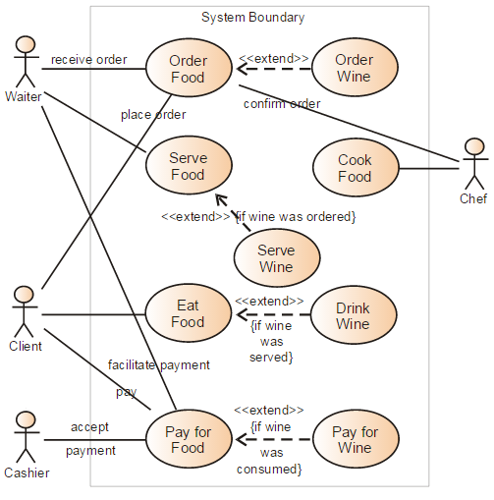

Figure : Sample use-case diagram

<<to insert caption for tables and figures, click on references on the top menu, under captions section 🡪 click insert caption 🡪 choose label as table

If you use a table, figure, or non-text item that is not your original design, you must cite the original source of the item. You may use an in-text citation in the text of the title or caption of the item, or you may include the citation as a footnote. Refer to the style manual of your discipline for more information about citations of non-text items.>>

* + 1. Class Diagram

<< Include a class diagram for all classes to be designed. Optionally include major data elements of those classes and important methods and functions that will be used by other classes.>>

**Example:** Online Photo Collection

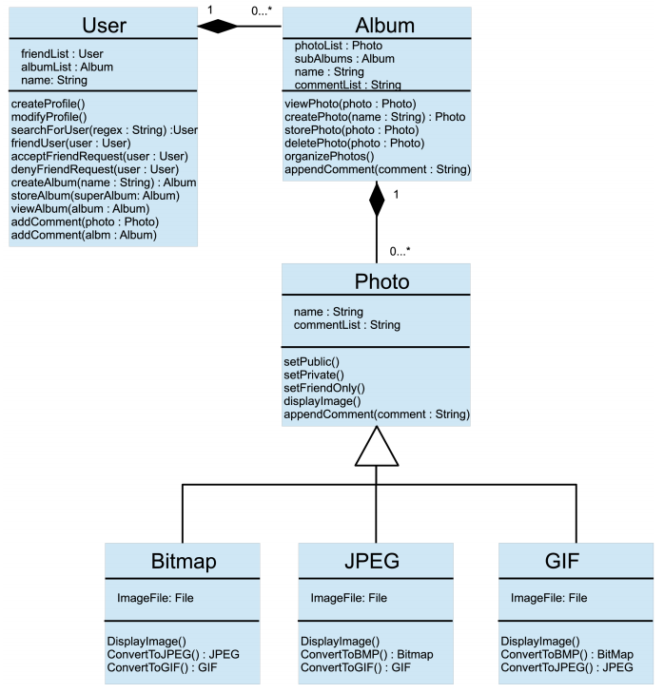

Figure : sample 2

* + 1. Activity Diagrams

The attached diagram describes the flow of events to reach the final goal of the project.

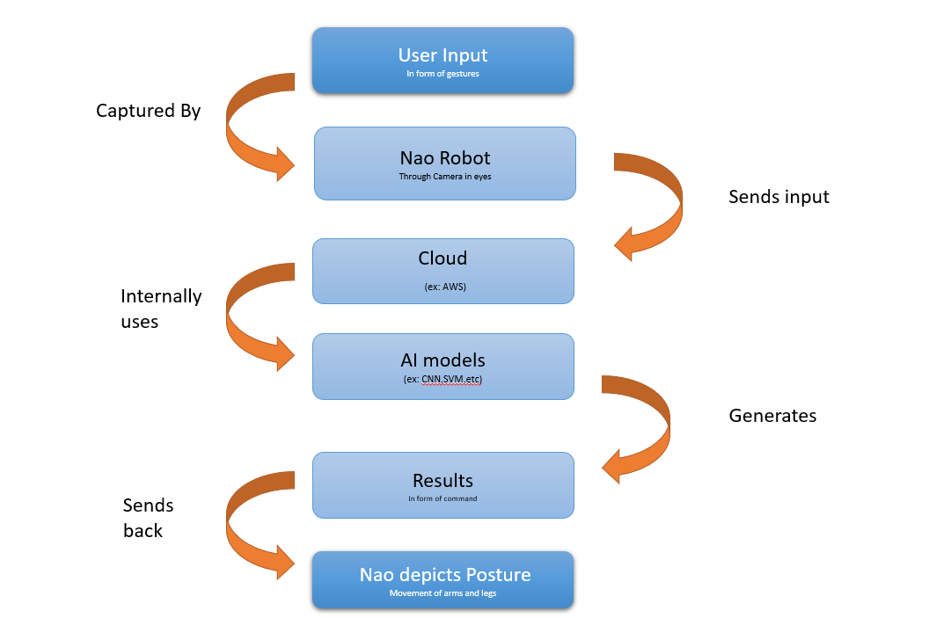

Figure : sample 3

* + 1. Sequence Diagram

<< Include sequence diagrams for important functionality of the program to indicate control flow. These diagrams should include classes found in the class diagram and use the methods for those classes to show the interaction between them. >>

Example: Create new album

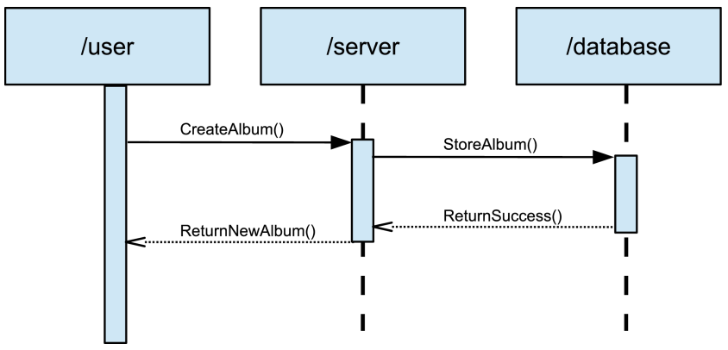

Figure : Sample 4

* + 1. Data Architecture

<< Include any information or diagrams that provide details about databases, xml configuration files, or other data structures that are a part of the system. If a very specific format is required, it may be worthwhile to provide a more robust description or a detailed design such as a database schema. >>

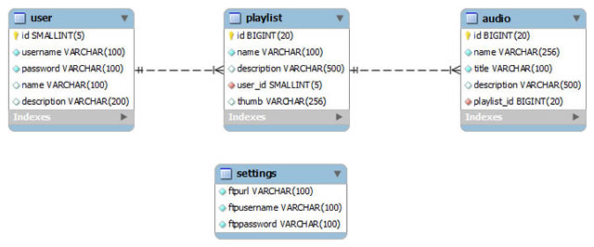

Figure : Sample 5

1. User Interface
   1. UI Description

Nao is a robot with basic machine User Interface. We start it with the power button on its chest. Then an IP address shall be taken from Nao by pressing the power button once and then we connect Nao to the Laptop with the software choreograph. When the user is ready and stands in front of Nao the image of the user will be captured once we click capture on the laptop. The ML model will process the picture and sends the classified pose to the Nao and Nao mimics the pose.

* 1. UI Mockup

The attached is the basic UI of Nao with the details of cameras, sensors and some other parts that are being used to mirror the pose.

Figure : Sample 6

1. Algorithms/Pseudo Code

<<Include the proposed algorithm/pseudo code.>>

1. Project Closure

The overall lookup of the project is as simple as saying u stand in front of a robot and the robot mimics your pose. The background part includes the pose classification using an ML model and sending the result to the Nao. This background work will be done on a laptop. The advancements in the project can be like making the whole thing in real time. This requires a lot of processing power in Nao which is a very difficult task.

* 1. Goals / Vision

The original vision was to make this whole project as a real time running project. But due to the limitations of Nao and complexities of joint movements it couldn’t be done. Instead we made it with some backend work attached to the Nao. Capturing the image of the user and processing it in an ML model and classifying the pose and then sending the result to Nao. Nao then processes the result and mimics the action. The goal has been reached but the vision had to be deviated by a bit due to the complexities.

* 1. Delivered Solution

Our project delivers primarily a robot model that can mimic the pose of the user with a pose classification machine learning model on a different processor other than Nao. Then that processor in this case a laptop gives the result to the Nao and then Nao processes the result and displays the action that was pre-programmed in the Nao with respect to the specific classification of the pose in the machine learning model. So, the outcome of the project will be Nao performing the pose that the user is displaying.

* 1. Remaining Work

The advancements of the project that can be done will be making this whole thing into a real time implementation. Like as soon as the user stands the Nao shall start behaving like the user in terms of poses. Nao has a limited processing power right now which limits it from doing this task. If a way of connecting Nao to a cloud and the performing this will be a major advancement. The task of performing this whole thing in a real time is very challenging and exciting. Due to time constraints we couldn’t make it possible. But given more time this is possible and can be made into very interesting and interacting project.

REFERENCES

[1] L. A. Fuente, H. Ierardi, M. Pilling, and N. T. Crook, “Influence of upper body pose mirroring in human-robot interaction,” in *Lecture Notes in Computer Science (including subseries Lecture Notes in Artificial Intelligence and Lecture Notes in Bioinformatics)*, 2015.

[2] M. Salem, F. Eyssel, K. Rohlfing, S. Kopp, and F. Joublin, “To Err is Human(-like): Effects of Robot Gesture on Perceived Anthropomorphism and Likability,” *Int J Soc Robot*, 2013.

[3] M. Salem, S. Kopp, I. Wachsmuth, K. Rohlfing, and F. Joublin, “Generation and Evaluation of Communicative Robot Gesture,” *Int J Soc Robot*, 2012.

[4] L. D. Riek, T. C. Rabinowitch, P. Bremner, A. G. Pipe, M. Fraser, and P. Robinson, “Cooperative gestures: Effective signaling for humanoid robots,” in *5th ACM/IEEE International Conference on Human-Robot Interaction, HRI 2010*, 2010.

[5] J. Gratch, W. Ning, J. Gerten, E. Fast, R. Duffy, and N. Wang, “Creating Rapport with Virtual,” in *7th International Conference on Intelligent Virtual Agents*, 2007.

[6] B. Gonsior *et al.*, “Improving aspects of empathy and subjective performance for HRI through mirroring facial expressions,” in *Proceedings - IEEE International Workshop on Robot and Human Interactive Communication*, 2011.

[7] C. Bartneck, D. Kulić, E. Croft, and S. Zoghbi, “Measurement instruments for the anthropomorphism, animacy, likeability, perceived intelligence, and perceived safety of robots,” *International Journal of Social Robotics*. 2009.

[8] T. Kanda *et al.*, “A humanoid robot that pretends to listen to route guidance from a human,” *Auton Robots*, 2007.

[9] S. Calinon, F. Guenter, and A. Billard, “On learning, representing, and generalizing a task in a humanoid robot,” *IEEE Trans Syst Man, Cybern Part B Cybern*, 2007.

[10] S. Calinon, F. Guenter, and A. Billard, “Goal-directed imitation in a humanoid robot,” in *Proceedings - IEEE International Conference on Robotics and Automation*, 2005.

[11] C. Stanton, A. Bogdanovych, and E. Ratanasena, “Teleoperation of a humanoid robot using full-body motion capture, example movements, and machine learning,” in *Australasian Conference on Robotics and Automation, ACRA*, 2012.

[12] K. Qian, H. Yang, and J. Niu, “Developing a gesture based remote human-robot interaction system using kinect,” *Int J Smart Home*, 2013.

[13] B. D. Argall, S. Chernova, M. Veloso, and B. Browning, “A survey of robot learning from demonstration,” *Rob Auton Syst*, 2009.

[14] C. Breazeal, “Social interactions in HRI: The robot view,” *IEEE Trans Syst Man Cybern Part C Appl Rev*, 2004.

[15] C. Breazeal and B. Scassellati, “Robots that imitate humans,” *Trends in Cognitive Sciences*. 2002.